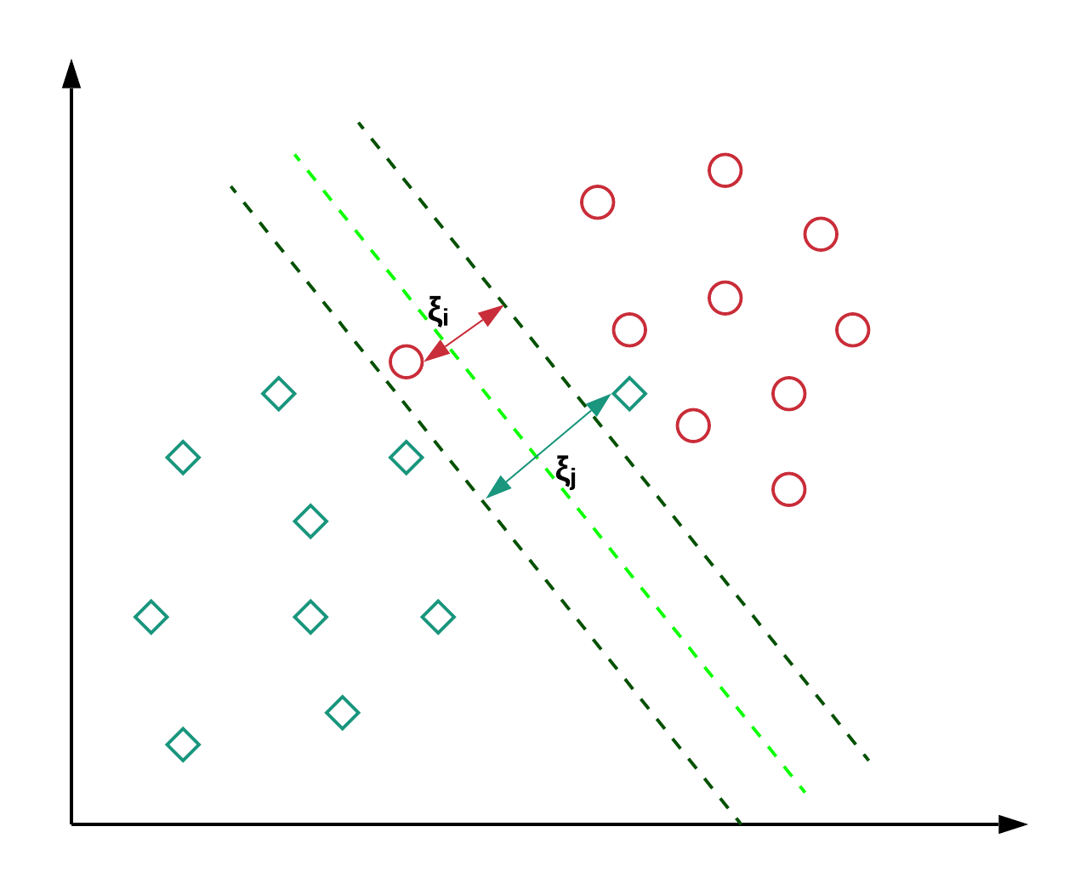
SVM’s soft margin formulation technique in action

Introduction
Support Vector Machine (SVM) is one of the most popular classification techniques which aims to minimize the number of misclassification errors directly. There are many accessible resources to understand the basics of how Support Vector Machines (SVMs) work, however, in almost all the real-world applications (where the data is linearly inseparable), SVMs use some advanced concepts.
Linear Inseparability
Before we move on to the concepts of Soft Margin and Kernel trick, let us establish the need of them. Suppose we have some data and it can be depicted as following in the 2D space:
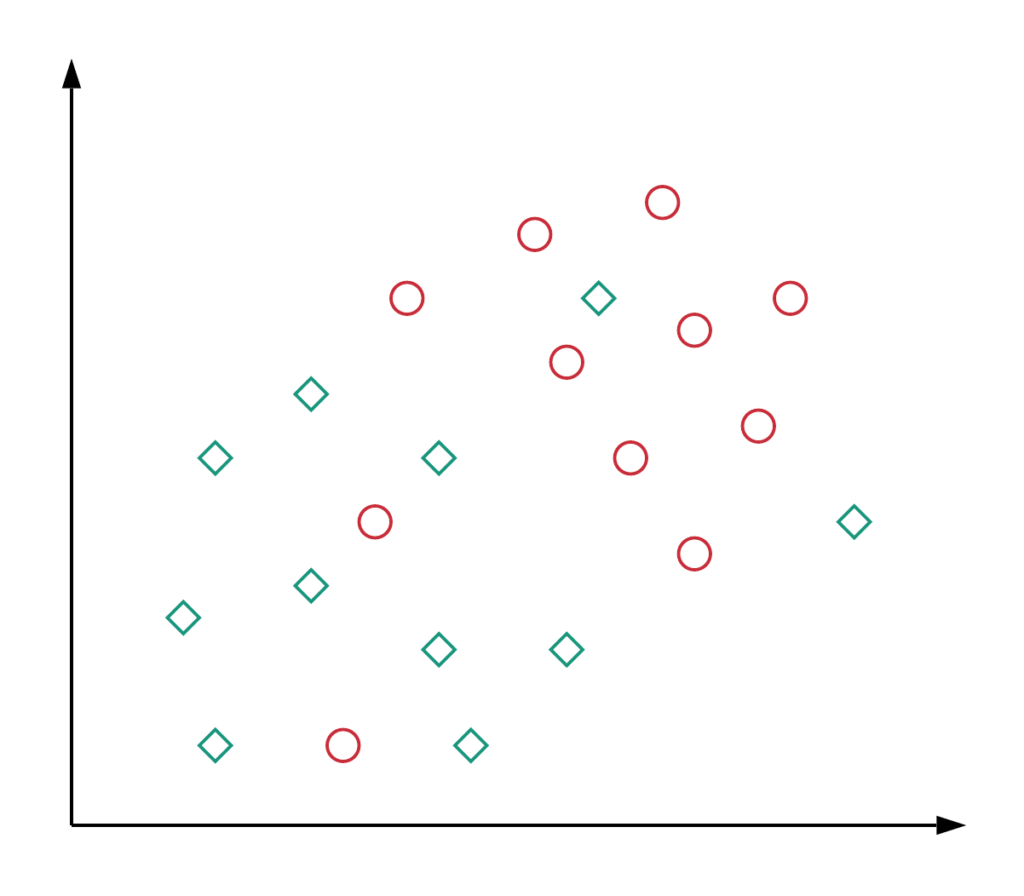
Figure 1: Data representation where the two classes are not linearly separable
From the figure, it is evident that there’s no specific linear decision boundary that can perfectly separate the data, i.e. the data is linearly inseparable. We can have a similar situation in higher-dimensional representations as well. This can be attributed to the fact that usually, the features we derive from the data don’t contain sufficient information so that we can clearly separate the two classes. This is usually the case in many real-world applications. Fortunately, researchers have already come up with techniques that can handle situations like these. Let’s see what they are and how they work.

Soft Margin Formulation
This idea is based on a simple premise: allow SVM to make a certain number of mistakes and keep margin as wide as possible so that other points can still be classified correctly. This can be done simply by modifying the objective of SVM.

Motivation
Let us briefly go over the motivation for having this kind of formulation.
- As mentioned earlier, almost all real-world applications have data that is linearly inseparable.
- In rare cases where the data is linearly separable, we might not want to choose a decision boundary that perfectly separates the data to avoid overfitting. For example, consider the following diagram:
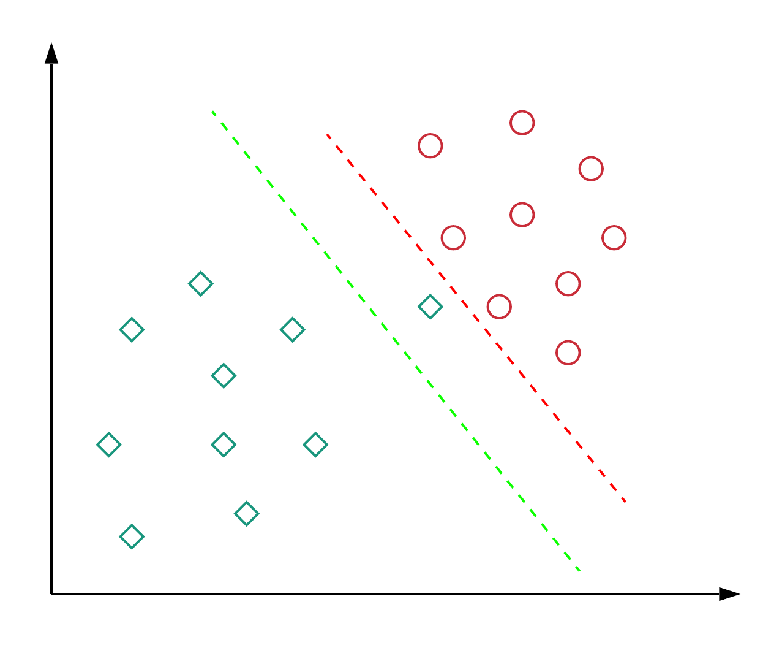
Figure 2: Which decision boundary is better? Red or Green?
Here the red decision boundary perfectly separates all the training points. However, is it really a good idea of having a decision boundary with such less margin? Do you think such kind of decision boundary will generalize well on unseen data? The answer is: No. The green decision boundary has a wider margin that would allow it to generalize well on unseen data. In that sense, soft margin formulation would also help in avoiding the overfitting problem.

How it Works (mathematically)?
Let us see how we can modify our objective to achieve the desired behavior. In this new setting, we would aim to minimize the following objective:
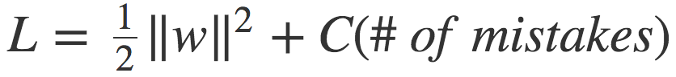
equation 1
This differs from the original objective in the second term. Here, C is a hyperparameter that decides the trade-off between maximizing the margin and minimizing the mistakes. When C is small, classification mistakes are given less importance and focus is more on maximizing the margin, whereas when C is large, the focus is more on avoiding misclassification at the expense of keeping the margin small.
At this point, we should note, however, that not all mistakes are equal. Data points that are far away on the wrong side of the decision boundary should incur more penalty as compared to the ones that are closer. Let’s see how this could be incorporated with the help of the following diagram.
Figure 3: The penalty incurred by data points for being on the wrong side of the decision boundary
The idea is: for every data point x_i, we introduce a slack variable ξ_i. The value of ξ_i is the distance of x_i from the corresponding class’s margin if x_i is on the wrong side of the margin, otherwise zero. Thus the points that are far away from the margin on the wrong side would get more penalty.
With this idea, each data point x_i needs to satisfy the following constraint:
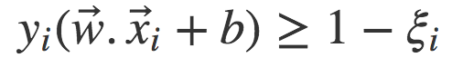
equation 2
Here, the left-hand side of the inequality could be thought of like the confidence of classification. Confidence score ≥ 1 suggests that classifier has classified the point correctly. However, if confidence score < 1, it means that classifier did not classify the point correctly and incurring a linear penalty of ξ_i.
Given these constraints, our objective is to minimize the following function:
equation 3
where we have used the concepts of Lagrange Multiplier for optimizing loss function under constraints. Let us compare this with SVM’s objective that handles the linearly separable cases (as given below).
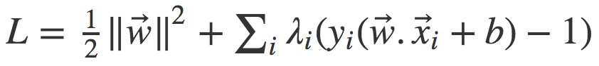
equation 4
We see that only ξ_i terms are extra in the modified objective and everything else is the same.
Point to note: In the final solution, λ_is corresponding to points that are closest to the margin and on the wrong side of the margin (i.e. having non-zero ξ_i) would be non-zero as they play a key role in positioning of the decision boundary, essentially making them the support vectors.

Kernel Trick
Now let us explore the second solution of using “Kernel Trick” to tackle the problem of linear inseparability. But first, we should learn what Kernel functions are.

Kernel Functions
Kernel functions are generalized functions that take two vectors (of any dimension) as input and output a score that denotes how similar the input vectors are. A simple Kernel function you already know is the dot product function: if the dot product is small, we conclude that vectors are different and if the dot product is large, we conclude that vectors are more similar. If you are interested in knowing about other types of Kernel functions, this would be a good source.

The “Trick”
Let us look at the objective function for the linearly separable case:
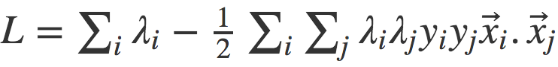
equation 5
This is a modified form of the objective in equation 4. Here, we have substituted the optimal value of w and b. These optimal values can be calculated by differentiating equation 4 with respect to these parameters and equating it to 0.
We can observe from equation 5 that objective depends on the dot product of input vector pairs (x_i . x_j), which is nothing but a Kernel function. Now here’s a good thing: we don’t have to be restricted to a simple Kernel function like dot product. We can use any fancy Kernel function in place of dot product that has the capability of measuring similarity in higher dimensions (where it could be more accurate; more on this later), without increasing the computational costs much. This is essentially known as the Kernel Trick.

How it Works (mathematically)?
A Kernel function can be written mathematically as follows:
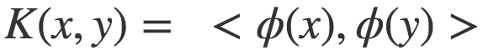
equation 6
Here x and y are input vectors, ϕ is a transformation function and < , > denotes dot product operation. In the case of dot product function, ϕ just maps the input vector to itself.
Kernel functions essentially take the dot product of transformed input vectors.
Now let us consider the case depicted in figure 4 below. We see that there is no linear decision boundary in 2d space that could perfectly separate the data points. A circular (or quadratic) decision boundary might do the job, however, linear classifiers are not capable of coming up with these types of decision boundaries.
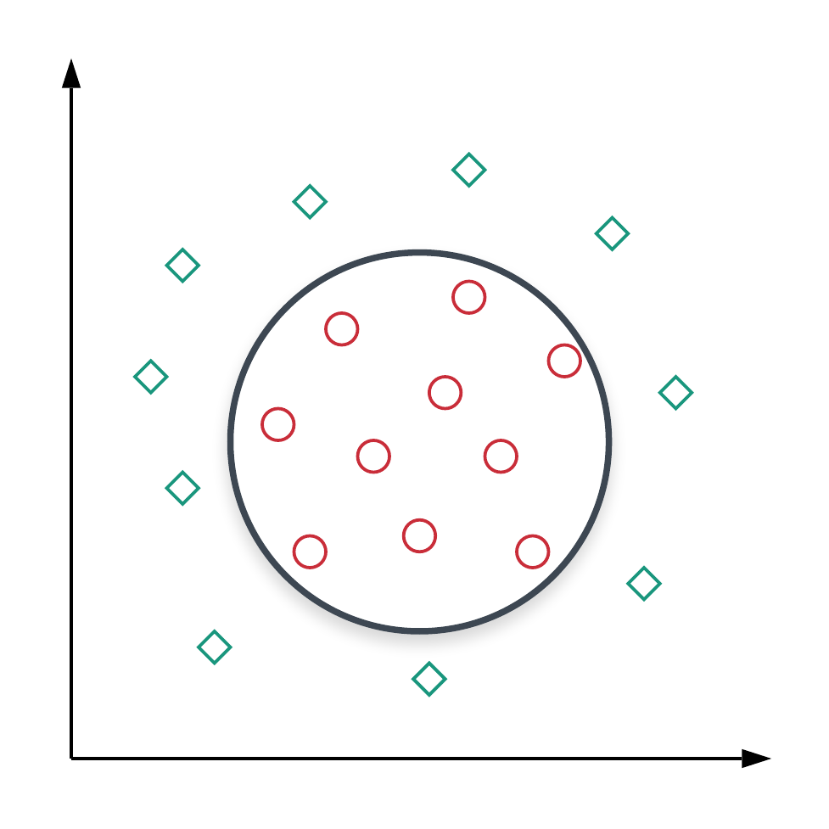
Figure 4: Points in 2D space are separable by a circular decision boundary.
In figure 4, each point P is represented by the features of form (x,y) in 2D space. Looking at the desirable decision boundary, we can define a transformation function ϕ for a point P as ϕ(P) = (x^2, y^2, √2xy) (why we came up with such a transformation would be clear in just a moment). Let’s see what the Kernel function looks like for this type of transformation for two points P_1 and P_2.
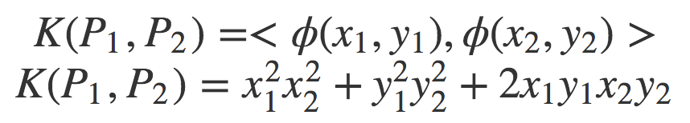
equation 7
If we observe the final form of the Kernel function, it’s nothing but a circle! This means we have changed our notion of similarity: instead of measuring similarity by how close the points are (using the dot product), we are measuring similarity based on whether points are within a circle. In this sense, defining such a transformation allowed us to have a non-linear decision boundary in 2D space (it is still linear in the original 3D space). It could be a lot to keep track of, so following is a brief summary of the decisions we have taken:

1 - Each point P is represented by (x,y) coordinates in 2D space.2 - We project the points to 3D space by transforming their coordinates to (x^2, y^2, √2xy)3 - Points which have high value of x.y would move upwards along the z-axis (in this case, mostly the red circles). This video provides a good visualization of the same.4 - We find a hyperplane in 3D space that would perfectly separate the classes.5 - The form of Kernel function indicates that this hyperplane would form a circle in 2D space, thus giving us a non-linear decision boundary.
And the main takeaway is:
By embedding the data in a higher-dimensional feature space, we can keep using a linear classifier!
A caveat here is that these transformations could increase the feature space drastically and that increases the computational costs. Is there any way we can reap the aforementioned benefits while not increasing the computational costs much? Turns out there is!
Let us try to rewrite the Kernel function in equation 7:
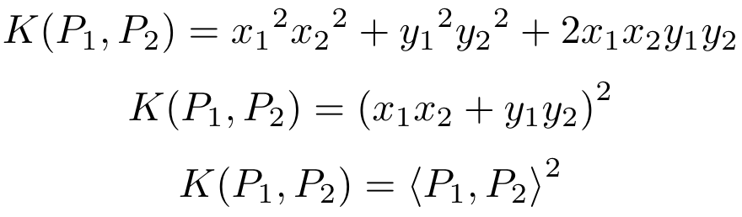
equation 8
Whoa! So the value of Kernel function (thus, the similarity between points in 3D space) is just the square of the dot product between points in 2D space. Pretty great, right?! But how did this happen?
The reason for this is that we chose our transformation function ϕ wisely. And as long as we continue to do that, we can circumvent the transformation step and calculate the value of Kernel function directly from the similarity between points in 2D space. This, in turn, would also curb the computational costs. We have many popular Kernel functions which have this nice property and can be used out of the box (we don’t need to search for perfect ϕ).
SVM Assumptions:

Before using Support Vector Machines (SVM), it's important to consider the following assumptions and conditions:

Linear Separability (for Linear SVM):

The basic form of SVM assumes that the data points are linearly separable, meaning they can be divided into distinct classes using a straight line (hyperplane in higher dimensions).
Kernel Selection (for Non-Linear SVM):

If the data is not linearly separable, a kernel trick can be used to map the data into a higher-dimensional space where separation is possible. However, the choice of the kernel and its parameters can significantly impact SVM performance.
Feature Scaling:

SVM is sensitive to the scale of features. Features should be scaled or normalized to ensure that no particular feature dominates the learning process due to its larger scale.
Binary Classification:

SVM is primarily designed for binary classification tasks, meaning it separates data into two classes. For multi-class problems, SVM can be extended through methods like one-vs-one or one-vs-rest.
Limited Noise and Outliers:

SVM assumes that the data is mostly clean and not significantly affected by noise or outliers. Outliers can have a disproportionate impact on the position of the hyperplane.
Homogeneous Data:

SVM assumes that the data is roughly homogeneously distributed across the classes. If one class has much fewer samples than the other, it could affect the balance between maximizing the margin and minimizing misclassification.
Low to Moderate Dimensionality:

SVMs can become computationally expensive and might not perform well in high-dimensional spaces due to the "curse of dimensionality."
Memory and Computational Resources:

SVM, especially with non-linear kernels, can require substantial memory and computational resources, especially for large datasets.
Choice of Regularization Parameter (C):

The parameter 'C' in SVM controls the trade-off between maximizing the margin and minimizing the classification error. It's crucial to choose an appropriate value through techniques like cross-validation.
Limited Training Data:

SVM performance can degrade if the training dataset is too small, as it may not capture the underlying patterns well.
Unbiased Representation:

SVM assumes that the training dataset is a representative sample of the population and not biased towards any particular class.
Class Imbalance Handling:

In cases of class imbalance, where one class has significantly fewer samples, SVM might need adjustments or the use of techniques to handle the imbalance.
Sensitivity to Parameter Tuning:

SVM performance can vary based on the choice of kernel, kernel parameters, and other hyperparameters. Parameter tuning is crucial for optimal results.
Understanding these assumptions and evaluating their applicability to your specific dataset is important to make informed decisions when using SVM for a particular problem.

Advantages and Disadvantages:

Support Vector Machines (SVM) offer various advantages and disadvantages, making them suitable for some scenarios and challenging for others. Here's a breakdown of the advantages and disadvantages of using SVM:

Advantages:

Effective in High-Dimensional Spaces:

SVM performs well even in high-dimensional spaces, making it suitable for problems with a large number of features.
Flexibility Through Kernels:

SVM can use different kernel functions to transform the data into higher dimensions, allowing it to handle non-linearly separable data and complex decision boundaries.
Robust to Overfitting:

SVM aims to maximize the margin between classes, which can help prevent overfitting by emphasizing generalization over fitting noise.
Global Optimum:

SVM optimization aims to find a global solution, ensuring the classifier's stability and reliability.
Effective with Small Datasets:

SVM can work well even when the dataset is relatively small, as it focuses on the most informative support vectors.
Interpretability with Linear Kernels:

Linear SVMs provide clear and interpretable decision boundaries, allowing insights into feature importance.
Works Well for Binary and Multi-Class Classification:

SVM can be used for both binary and multi-class classification tasks through various strategies like one-vs-one or one-vs-rest.
Tolerant of Irrelevant Features:

SVM is relatively unaffected by irrelevant features, as it focuses on the support vectors that define the decision boundary.
Disadvantages:

Computationally Intensive:

Training SVM models, especially with non-linear kernels and large datasets, can be computationally intensive and time-consuming.
Sensitivity to Parameter Tuning:

SVM's performance is sensitive to the choice of kernel, kernel parameters, and regularization parameter (C), requiring careful tuning.
Memory Usage:

SVM can require significant memory resources, particularly when working with large datasets or high-dimensional feature spaces.
Doesn't Handle Large Datasets Well:

SVM's training time and memory usage can make it less suitable for very large datasets, where training time becomes a bottleneck.
Difficulty Handling Noisy Data and Outliers:

SVM's emphasis on maximizing the margin can make it sensitive to noisy data and outliers, potentially affecting the decision boundary.
Limited to Two-Class Classification:

SVM's original formulation is for binary classification, requiring extensions for multi-class problems.
Lack of Probabilistic Output:

SVM doesn't provide probabilistic output by default. Additional methods like Platt scaling are needed to estimate probabilities.
Complexity of Kernel Selection:

Choosing an appropriate kernel and tuning its parameters can be challenging and require domain knowledge.
Interpretability Challenges with Non-Linear Kernels:

Non-linear SVMs with complex kernels can produce intricate decision boundaries that are less interpretable.
SVMs are a powerful tool, particularly when the dataset is well-suited to its assumptions and the parameters are well-tuned. However, the choice of SVM should be made considering the specific characteristics of the problem and the available computational resources.

Support Vector Machines (SVM) can also be used for regression tasks, which is known as Support Vector Regression (SVR). SVR is a variant of SVM that aims to predict a continuous output variable instead of class labels. The primary idea behind SVR is to find a function that fits the data while minimizing the deviation of predictions from the actual target values. Here's how regression is performed using SVR:

Data Representation:

Similar to classification, you have a dataset with input features (X) and corresponding continuous target values (y).
Kernel Selection:

Choose an appropriate kernel function. Common choices include linear, polynomial, radial basis function (RBF), and sigmoid kernels.
Loss Function:

Unlike classification, SVR aims to minimize the deviation between the predicted values and the actual target values. The loss function used in SVR is called the epsilon-insensitive loss function.
Epsilon (ε) Tube:

In SVR, an epsilon (ε) tube is created around the predicted values. Data points within this tube are considered as correctly predicted, and the model doesn't penalize deviations within this range.
Support Vectors:

SVR identifies the data points that fall outside the epsilon tube. These are the support vectors that contribute to the loss function.
Optimization:

The goal is to find the model parameters (weights and bias) that minimize the loss function while satisfying the constraint of keeping the deviations within the epsilon tube.
Regularization:

Similar to classification, regularization is introduced through the regularization parameter (C) to control the trade-off between fitting the training data and maintaining a simple model.
Solution Optimization:

SVR formulates the optimization problem as a convex quadratic programming problem, similar to the classification problem. The optimization algorithm finds the optimal weights and bias that minimize the loss function while respecting the margin and epsilon tube constraints.
Prediction:

Once the model is trained, you can use it to make predictions on new data points. The predicted value is the regression output, and it lies within the epsilon tube.
Tuning Hyperparameters:

Just like in classification, the choice of kernel, kernel parameters, and regularization parameter (C) must be tuned to achieve the best performance on the validation set or through cross-validation.
It's important to note that SVR aims to find a balance between fitting the training data well and avoiding overfitting, which is achieved by controlling the width of the epsilon tube and the regularization parameter. Additionally, SVR doesn't predict exact target values but rather approximates them within the epsilon tube, which can be adjusted based on the problem's requirements.
The mathematics behind Support Vector Regression (SVR) involves formulating an optimization problem that aims to find a function that fits the data while minimizing the deviations from the target values. Here's the mathematical formulation of SVR:

Objective Function:
The goal is to minimize the following objective function:
0.5 * ||w||^2 + C * Σ(max(0, |yi - f(xi)| - ε))
w represents the weight vector.
C is the regularization parameter, controlling the trade-off between fitting the data and preventing overfitting.
Σ indicates the summation over all data points (i = 1 to N).
yi is the target value for the i-th data point.
f(xi) is the predicted output for the i-th data point using the learned function.
ε is the width of the epsilon-insensitive tube.
Constraints:
The optimization problem has constraints to ensure that the deviations are within the epsilon tube:
yi - f(xi) <= ε
f(xi) - yi <= ε
Loss Function:
The loss function in SVR is the sum of the hinge loss applied to the deviations:
max(0, |yi - f(xi)| - ε)
This loss is 0 if the deviation is within the epsilon tube (no penalty), and it increases linearly as the deviation moves outside the tube.

Dual Formulation:
Similar to Support Vector Machines (SVM) for classification, SVR has a dual formulation. The optimization problem is transformed into its dual form, which involves Lagrange multipliers (αi) associated with each data point.

Dual Optimization Problem:
The dual optimization problem is to maximize the Lagrangian:

L = Σαi - 0.5 * ΣΣ αi * αj * yi * yj * K(xi, xj)
αi are the Lagrange multipliers.
K(xi, xj) is the kernel function applied to the input data points.
The first term encourages the sum of Lagrange multipliers to be large, while the second term involves the dot products of data points and their targets to form the deviations.
Solution and Prediction:
After solving the dual optimization problem, the optimal Lagrange multipliers are found. The predicted output for a new data point x is given by:

f(x) = Σαi * yi * K(x, xi) - b
where b is the bias term.

Kernel Trick:
The kernel trick is used to implicitly compute the dot product of data points in higher-dimensional feature space, even without explicitly transforming the data. Common kernel functions include linear, polynomial, radial basis function (RBF), and sigmoid kernels.

Working with Non-Linear Data:
SVR with non-linear kernels can capture complex relationships between input features and target values. The kernel functions allow SVR to model data that cannot be linearly separated in the original feature space.

Solving the dual optimization problem using algorithms like Sequential Minimal Optimization (SMO) or other quadratic programming methods provides the optimal Lagrange multipliers, which, in turn, define the SVR model for making predictions on new data points.

